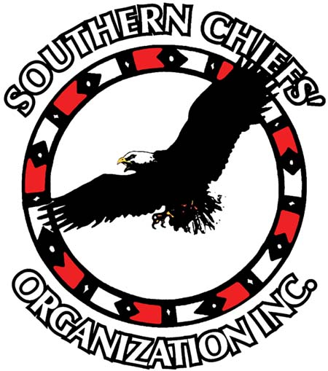
Winnipeg Sub-Office

105-1555 St. James St. Winnipeg, Manitoba R3H 1B5

Phone: (204) 946-1869 Fax: (204) 946-1871

Toll Free: 1-866-876-9701 www.scoinc.mb.ca

Head Office

Long Plain First Nation

Box 998

Portage La Prairie, MB

R1N 0P0 www.scoinc.mb.ca

FOR IMMEDIATE RELEASE

GRAND CHIEF TERRANCE NELSON CONSIDERS THE TSILHQOT’IN DECISION A MAJOR VICTORY FOR ALL FIRST NATIONS IN CANADA

WINNIPEG, JUNE 26, 2014 – Grand Chief Terrance Nelson acknowledges the significance of the Tsilhqot’in First Nation and today’s major court victory: “I congratulate and thank the people and leadership of the Tsilhqot’in First Nation for their perseverance in pursuing this claim to Aboriginal Title over their traditional territory. Today’s decision by the Supreme Court of Canada will benefit all First Nations”.

In a historic decision, the Supreme Court of Canada confirmed aboriginal title to more than 1700 square kilometers of land in British Columbia to the Tsilhqot’in First Nation.

The judgment also brings legal clarification on a number of concepts pertaining to aboriginal law. For Attorney Normand Boudreau who specializes in Indigenous law: “..the Tsilhqot’in decision clarifies the federal and provincial roles…There can be no more hiding behind the division of powers between jurisdictions. The Supreme Court of Canada made it very clear today that Indigenous rights impose limits on all level of governments.” Boudreau suggests that this decision could have a major impact on different outstanding legal issues in Manitoba: “For instance, on the Kapyong file this landmark decision will enhance the requirement of reconciliation and good faith negotiations between Treaty One First Nations and Canada.”

For Grand Chief Nelson, today’s decision by the Supreme Court should help First Nations develop stronger economies: “The decision confirms the need for governments to not only consult First Nations but also obtain our consent before proceeding with any projects that impact our ancestral lands. The Court went further by stipulating that compensation will be required when we do not consent to projects. For me, this means that First Nations can no longer be systematically and economically excluded from major projects.”

The Southern Chiefs Organization represents 33 First Nations located in southern part of the province of Manitoba, Canada. For more information on SCO, visit www (weblink)

Contact Grand Chief Terrance Nelson at (204) 946-1869, (204) 223-7730 or via email at grandchiefnelson@scoinc.mb.ca

“Representing Anishinaabe, Cree and Dakota First Nations in Southern Manitoba”

